


BigFix Platform
AVP/PS Diagnostic
Workbench
User Guide

VERSIONING
Document Control

Version | Date | Notes
2.0 Draft | 09-20-2026 | Draft -- User Guide for BigFix Platform AVP/PS Diagnostic Workbench v2.0.
1.1 | 08-28-2026 | User Guide for Report Builder v1.1.
1.0 | 07-21-2026 | Initial guide baseline for Report Builder v1.0.

CONTENTS
Table of Contents

Before You Start 4
1.1 Requirements 4
Setting Up 6
2.1 Install Python 6
2.2 Launch The Workbench 6
2.3 If Setup Fails 8
Workbench Workflow 9
3.1 Two Ways To Run 9
3.2 Header Controls 9
Run Individual Modules 12
4.1 Common Tasks 12
4.2 Run One Or More Modules 13
Step 1: Folders And Run Details 14
Step 2: Modules 16
6.1 Run Mode 16
6.2 Presets 16
6.3 Module Dependencies 17
6.4 Statuses 18
6.5 Open A Module For Review 19
6.6 Server Capacity Analysis 20
6.7 Client Loop Detail 22
Step 3: Build 24
7.1 Output Terms 24
7.2 Build Progress 25
7.3 Update Run 26
Findings & Scoring Review 27
8.1 Worksheets 27
8.2 Platform Health Findings 28
8.3 Operational Findings 29
8.4 Operational Maturity Review State 29
8.5 What Needs Attention 30
8.6 Impact And Remediation Windows 30
Step 4: Validation 31
9.1 Refresh After Workbook Changes 31
9.2 Run Validation 31
Troubleshooting 32
Delivery Gates 33
Security And Data Handling 34
12.1 Local Processing 34
12.2 The Private Python Environment 34
12.3 Data Handling Rules 34
12.4 Layered Security Controls 35
12.5 The Release Sweep 36
12.6 Answering Customer Questions 36
Module Reference 38
A.1 Report Modules 39
A.2 Findings and Narrative 40
A.3 Experimental Modules 41

Section 01


Before You Start

The BigFix Platform AVP/PS Diagnostic Workbench is a diagnostic multi-tool for the BigFix platform. Each analysis runs as a module.
Run individual modules for day-to-day work such as client performance, PerfMon counter, FillDB performance, or server capacity analysis. Use Full Report mode to build a draft Platform Health Check report when an assessment calls for one.
A technical consultant reviews every output before it reaches a customer.
📝 NOTE The Workbench reads the files you select and writes results to local folders. It does not connect to live BigFix or SQL systems, upload customer data, or use customer credentials. See Section 12.

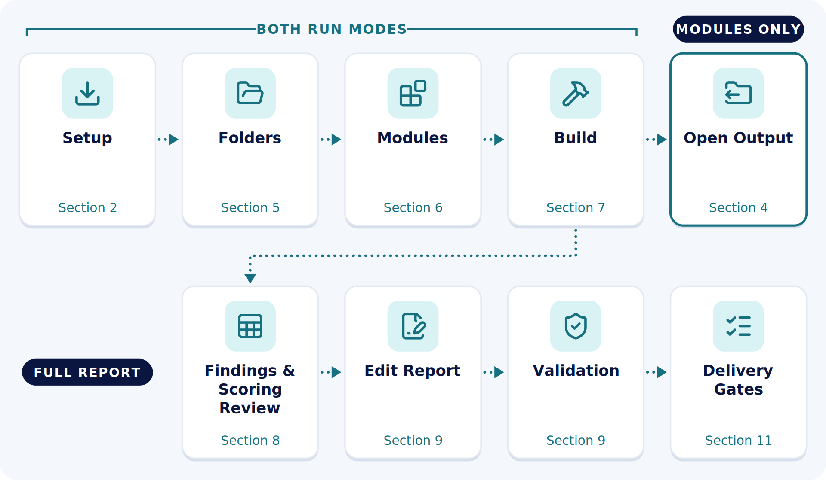
Figure 1. The two ways to use the Workbench, with the guide section for each stage.

1.1 Requirements
Item | Requirement
Operating system | Windows 11, or macOS for every module except Perfmon.
Python | Install Python 3.12 or later on the computer that runs the Workbench.
Collected data | Use a Results folder produced by the current collection tasks. Individual module inputs can also be selected on Step 2.
BigFix account | Before collection begins, the customer creates a dedicated temporary BigFix account with the permissions listed in the collection instructions. Do not use a personal account or an existing service account. The customer disables or removes the account when collection is complete.
Report template | Use the reporting template included with the Workbench. Full Report mode selects the newest dated template automatically.
Output location | Select a folder where the Workbench can create a timestamped run folder.
Browser | Install Microsoft Edge or Google Chrome for chart rendering.
uv | Install uv before the first launch. The launcher uses it to build the private Python environment.

📝 NOTE A dedicated account keeps the collection permissions scoped to the engagement. Every task and API call made during collection is attributable to that account, which simplifies troubleshooting.

💡 TIP Complete a practice run with approved lab data before using the Workbench for a customer assessment.
Section 02


Setting Up

There is no installer. The Workbench is portable. It finds its template and files relative to its own folder. It runs from wherever it is placed.

2.1 Install Python
- Install Python 3.12 or later from python.org.
- Windows: Accept any prompt to add Python to PATH or to make it available from the terminal.
- macOS: Run the installer package. Then run Install Certificates.command from the Python folder under /Applications to finish the SSL setup.
- Open a new terminal and confirm the version.
- Windows: Run python --version or py -3 --version. The launcher checks both.
- macOS: Run python3 --version.
- The version must be 3.12 or later.
- Install uv. This step is needed only once.
- Windows: Run winget install --id=astral-sh.uv -e.
- macOS: Run brew install uv. Reopen the terminal and confirm with uv --version.
📝 NOTE The launcher installs the exact package versions pinned in the lockfile. Every pinned version is at least 7 days old. See 12.2 The Private Python Environment.

2.2 Launch The Workbench
On Windows, run Launchers\Run Report Builder.cmd. On macOS, run Launchers/Run Report Builder.command.
The first launch creates a private Python environment and installs the required packages. The launcher does not change the global Python environment.
The report build reads local inputs. Collection tools and the Release Intelligence Collector run separately.
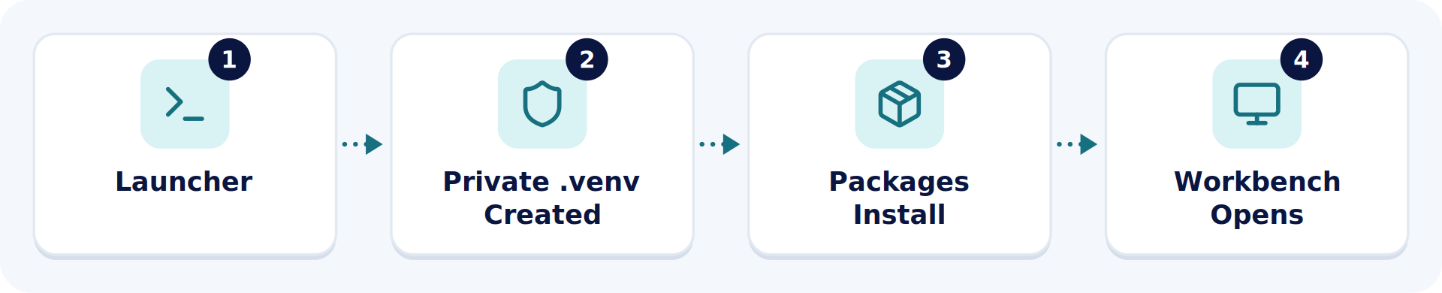
Figure 2. The first launch builds a private environment, installs packages, and opens the Workbench.
- Copy the Workbench folder to a short top-level path. Use C:\BigFix Health Check\ on Windows or ~/BigFix Health Check/ on macOS.
- Double-click the launcher for your operating system.
- macOS: If macOS blocks the file, open Terminal in the Launchers folder. Run chmod +x "Run Report Builder.command". Launch it again.
- Acknowledge the first-run notice. The console explains that packages go into the private environment. On Windows, press any key. On macOS, press Enter.
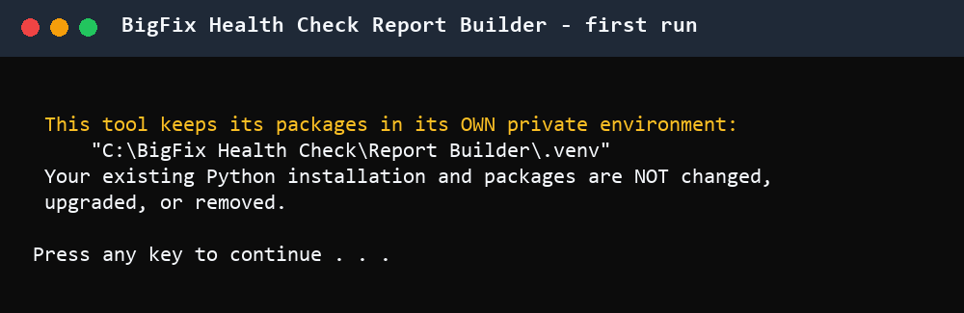
Figure 3. The first-run notice. The existing Python installation is not changed.
- Let the install finish. The first run takes a few minutes. With uv, the console shows the lockfile install. Later launches skip this step.
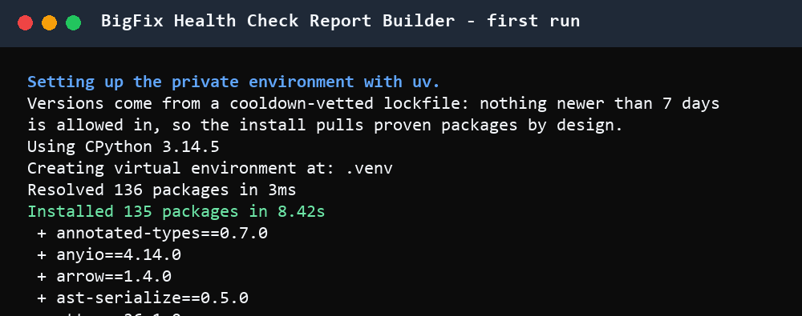
Figure 4. Packages installing from the lockfile with uv.
- Confirm the hand-off. The console prints the launch message and the Workbench opens at Step 1. Setup is complete.
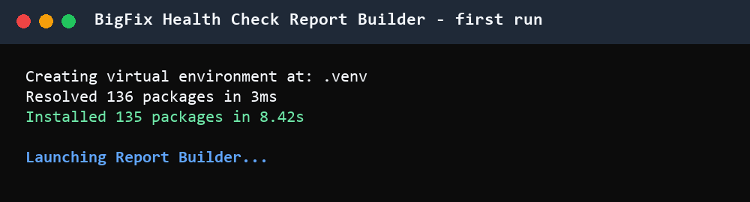
Figure 5. Install complete. The launcher hands off to the Workbench.
- Confirm that Microsoft Edge or Google Chrome is installed. Charts render through the installed browser. If neither browser is found, chart generation stops with an error.
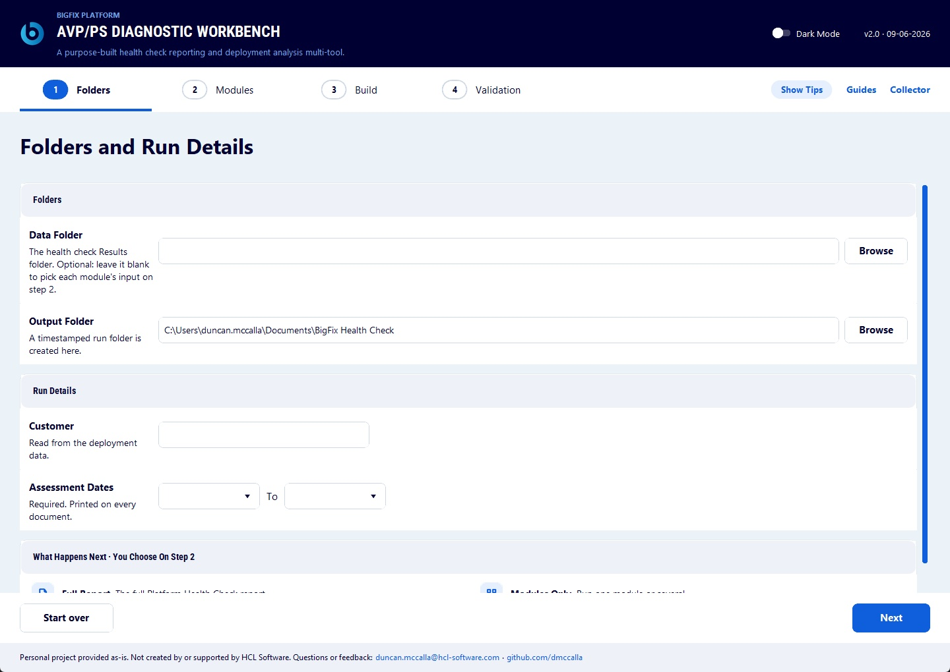
Figure 6. Workbench after launch.

2.3 If Setup Fails
Problem | Action
Python was not found. | Open a new terminal and check the version. On Windows, run python --version or py -3 --version. On macOS, run python3 --version. If neither works, reinstall Python with command-line access enabled.
Python is older than 3.12. | Install Python 3.12 or later. Run the launcher again.
Package installation failed. | Close the console. Delete the .venv folder inside the Workbench folder. Run the launcher again. If the failure repeats, check internet access and SSL inspection. On macOS, confirm that Install Certificates.command was run.
The console opens and closes immediately. | Run the launcher from a terminal so the error stays visible. Open a terminal in the Launchers folder and start the launcher there.
Section 03


Workbench Workflow

The Workbench has four navigation steps.
- Folders.
- Modules.
- Build.
- Validation.

3.1 Two Ways To Run
Step 2 offers two run modes. Both use the same four navigation steps.
Topic | Modules Only | Full Report
Use It For | Day-to-day analysis such as client performance, PerfMon counters, FillDB performance, or server capacity. | A Platform Health Check assessment.
Produces | The outputs of the selected modules. The Full Report is not assembled. | The main report and the outputs produced by the selected modules.
Word Template | Not used. | Required. The newest dated template is selected automatically.
Required Modules | None. Four modules also select Deployment Information. See 6.3 Module Dependencies. | Four, selected automatically. See 6.3 Module Dependencies.
Findings & Scoring Review | The build does not pause. | The build pauses when Health Check Findings runs.
Validation | Not used. | Required before delivery.
Guide Sections | Section 4. | Sections 5 to 9 and Section 11.

3.2 Header Controls
Control | Action
Show Tips or Hide Tips | Show or hide help for the current step. The Workbench saves the preference.
Guides | Open the Start Here window with the User Guide and Procedural Guide locations.
Collector | Open the Release Intelligence Collector. The collector can use internet sources.
Start over | Clear the current workflow after confirmation and return to Step 1. This action cannot be undone.
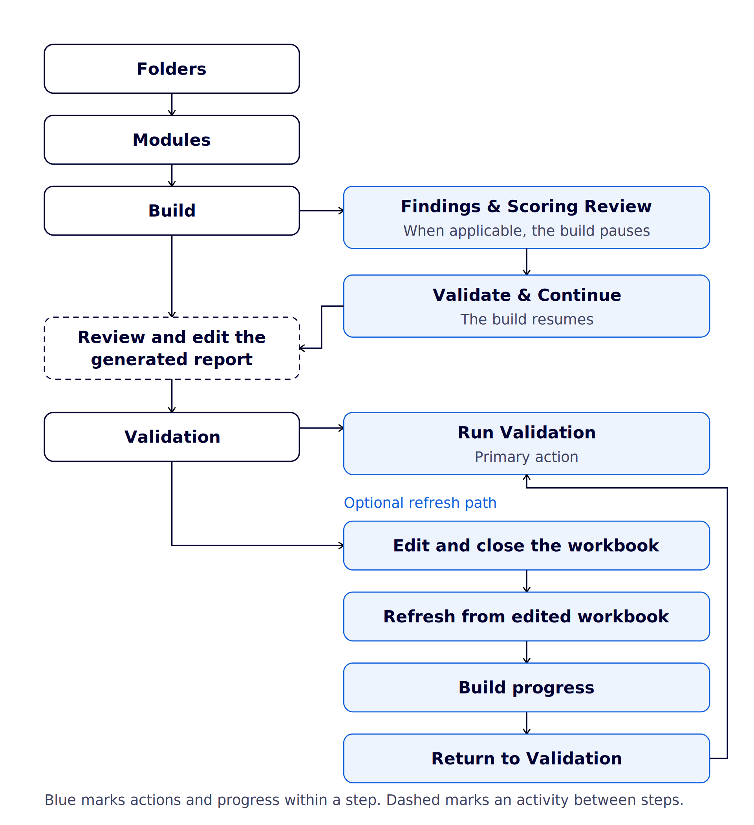
Figure 7. The four Workbench steps and the optional workbook refresh path.
Section 04


Run Individual Modules

Modules Only runs the selected modules without assembling the Full Report. Use it for day-to-day analysis. Each selected module writes its outputs to a timestamped run folder in the Output Folder.

4.1 Common Tasks
Task | Module
Analyze client loop timing, UDP notification coverage, and command polling. | Client Loop Health Check
Analyze PerfMon counters from a BigFix platform server. | Perfmon Infrastructure Analysis
Review FillDB processing performance. | FillDB Performance
Compare server and relay resources with published BigFix capacity figures. | Server Capacity Analysis
Review release and known-issue information for upgrade planning. | Release Intelligence
Prepare client setting suggestions for a tuning discussion. | Client Settings Suggester
Analyze collected server logs. | Server Log Analysis
Review the deployment health checks. | Deployment Health Check Dashboard
Review the deployment overview. | Deployment Overview
Review SQL Server and database information. | SQL Database Information

Appendix A describes the inputs, outputs, and review for each module. To update one module in a finished Full Report, see 7.3 Update Run.

4.2 Run One Or More Modules
- On Folders, set up the run.
- Select the Output Folder.
- Select the Data Folder when the inputs are in a collected Results folder. Leave it blank to select each input on Step 2.
- Confirm the Customer. Enter the Assessment Dates.
- On Modules, select Modules Only.
- Select only the modules you need. Open Details on each one.
- The open row shows what the module does, when to use it, and the inputs it looks for.
- Four modules also select Deployment Information. See 6.3 Module Dependencies.
- Resolve every selected module at Needs A File or Needs Review. See 6.5 Open A Module For Review.
- Select Next when every selected module is ready.
- On Build, review the run details. The module list shows the outputs each module will produce.
- Select Build. When the build finishes, select Open Output.
📝 NOTE A Modules Only run ends at Open Output. The build does not pause for the Findings & Scoring review. Validation applies only to the Full Report.
Section 05


Step 1: Folders And Run Details

Step 1  Folders | Step 2  Modules | Step 3  Build | Step 4  Validation

Step 1 identifies the collected data, output location, customer, and assessment dates.
Field | Action
Data Folder | Select the collected Results folder. Leave it blank only when module inputs will be selected separately on Step 2.
Output Folder | Select the parent folder for the timestamped run folder.
Customer | Confirm the customer name. The Workbench uses the detected name when available.
Assessment Dates | Enter the start date and end date. The end date cannot be earlier than the start date.

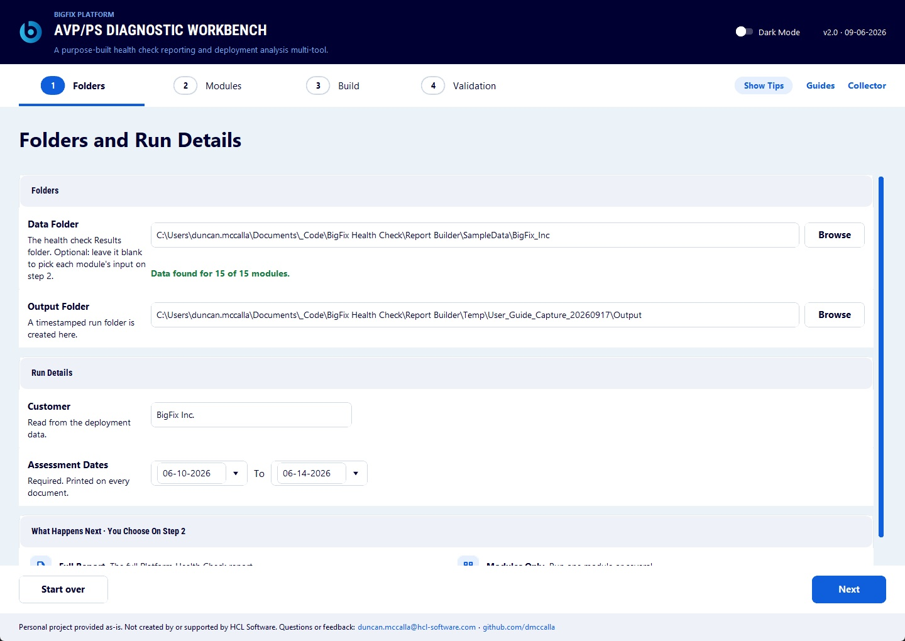
Figure 8. Step 1 with valid folders and run details.
The Workbench scans the Data Folder for module inputs. The scan summary reports how many inputs were found and identifies missing inputs.
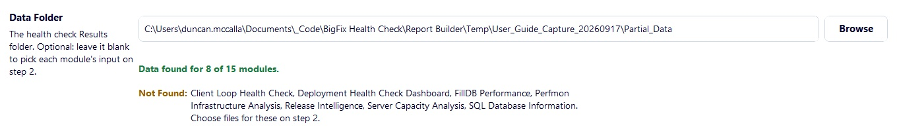
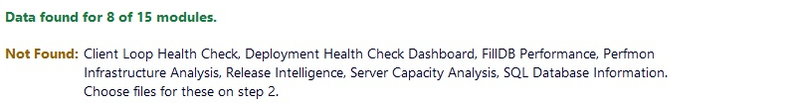
Figure 9. Step 1 scan summary.
📝 NOTE A missing input does not block Step 1. It blocks Step 3 only when the affected module is selected and still requires the input.
Section 06


Step 2: Modules

Step 1  Folders | Step 2  Modules | Step 3  Build | Step 4  Validation

Step 2 controls the run mode, selected modules, report template, module inputs, and required reviews.

6.1 Run Mode
Mode | Result
Full Report | Build the main report and the outputs produced by the selected modules. The Standard preset is applied.
Modules Only | Run the selected modules without assembling the Full Report.

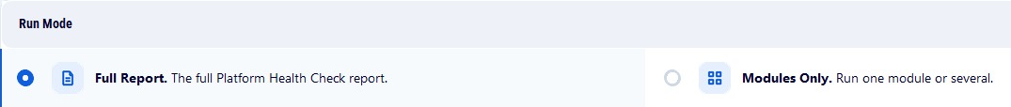
Figure 10. The two run modes on Step 2.
Word Template appears in Full Report mode. The Workbench selects the newest dated template in Templates. Select Change only when a different approved template is required.
An asterisk marks a module that must remain selected for a new Full Report. The required modules are:
- Deployment Overview.
- Deployment Health Check Dashboard.
- Deployment Information.
- SQL Database Information.
The page displays * Required for the Full Report. beneath Report Modules.

6.2 Presets
Preset | Action
Standard | Select detected modules in Report Modules and Findings and Narrative. Required Full Report modules remain selected.
All Available | Select every module that can currently run. This includes Experimental Modules.
Clear | Clear optional selections. Required Full Report modules remain selected in Full Report mode.

Into Report controls whether a selected module adds its supported content to the Full Report. It does not select or unselect the module.
Into Report is unavailable for Client Settings Suggester, Server Log Analysis, and Health Check Analysis (Supporting Reference). These modules produce separate files only.
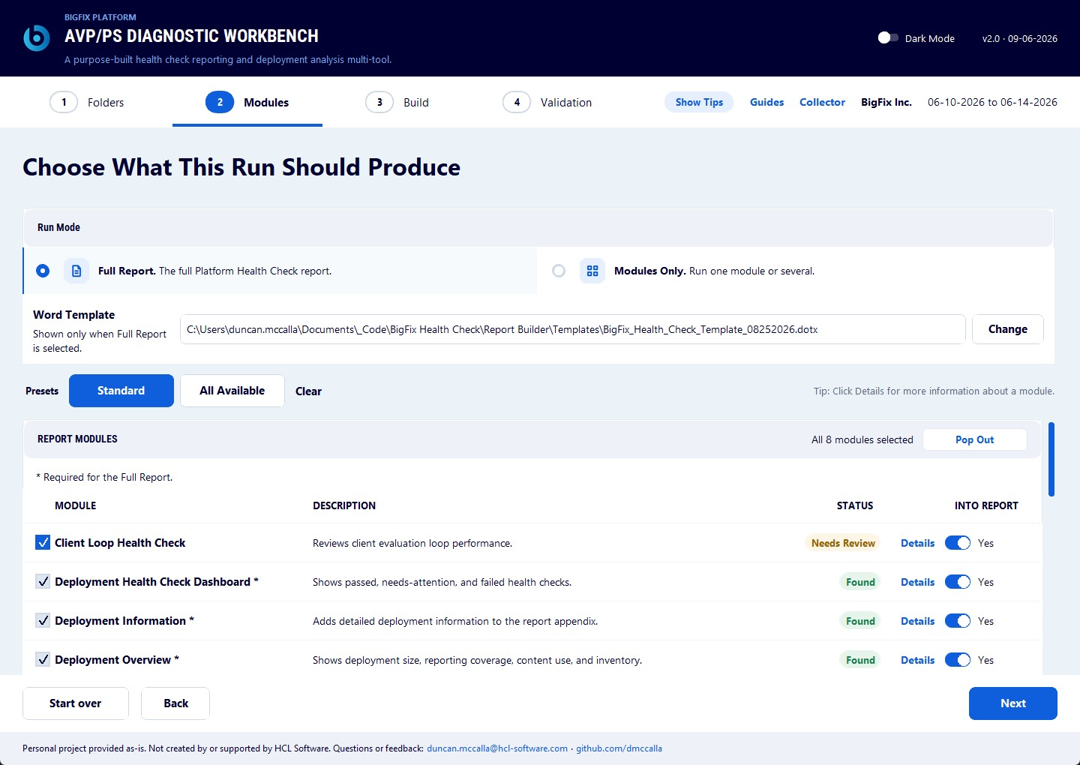
Figure 11. Step 2 in Full Report mode with Standard selected.

6.3 Module Dependencies
Step 2 selects some modules automatically. The rules depend on the kind of run.
Run | Rule
New Full Report | Deployment Overview, Deployment Health Check Dashboard, Deployment Information, and SQL Database Information are selected automatically. They cannot be cleared.
Modules Only | The four required Full Report modules are not imposed. Select individual modules, subject to the Deployment Information dependency.
Update Run | The four required-module locks are removed. Select only the modules that must run again. Output from unselected modules is reused from the earlier run.

Selecting any of these modules also selects Deployment Information. This applies in Full Report mode, Modules Only, and update runs.
- Health Check Findings (Check Table Cells).
- What's Working Well.
- Health Check Analysis (Supporting Reference).
- Client Settings Suggester.
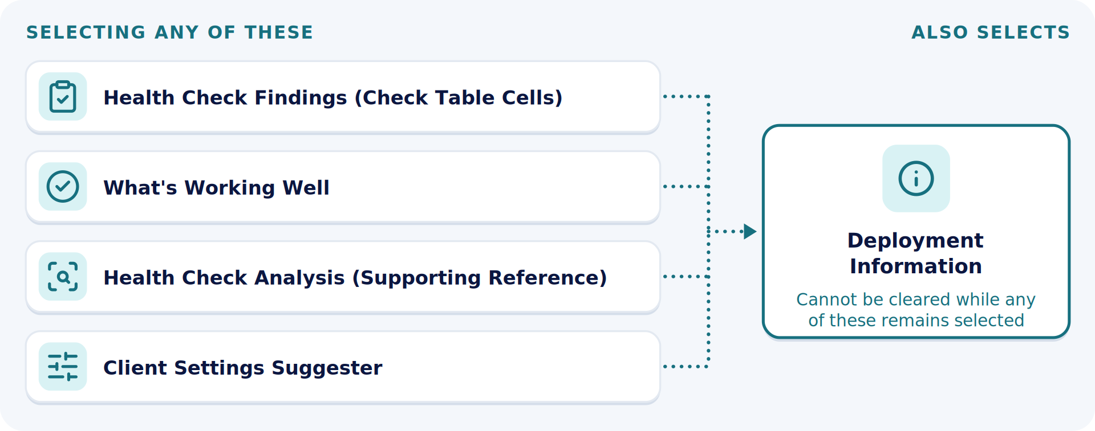
Figure 12. The four modules that also select Deployment Information.
📝 NOTE Deployment Information cannot be cleared while any of these modules remains selected.

Client Loop Health Check requires the report dates in Full Report mode. The report dates are optional in Modules Only.
No other module selects another module on Step 2.

6.4 Statuses
Status | Meaning | Action
Found | The expected input was found. | Continue unless the open row requires confirmation.
Scans Data Root | The module can scan the selected Data Folder. | Confirm that the Data Folder is correct.
Needs A File | A required input was not found or cannot be used. | Open Details and select a valid input. Unselect the module when allowed.
Scanning | Input detection is running. | Wait for the scan to finish.
Not Scanned | The Data Folder has not been scanned. | Select a valid Data Folder or choose the module input directly.
Needs Review | The selected module requires consultant action. | Open Details and follow the action shown for that module.
Reviewed | The required module review is recorded. | Continue when every selected module is ready.

📝 NOTE Next checks the selected modules, required reviews, required inputs, and the Full Report template. A selected module at Needs A File, Scanning, Not Scanned, or Needs Review blocks Step 3.

6.5 Open A Module For Review
- Find a selected row marked Needs Review.
- Select Details at the end of the row.
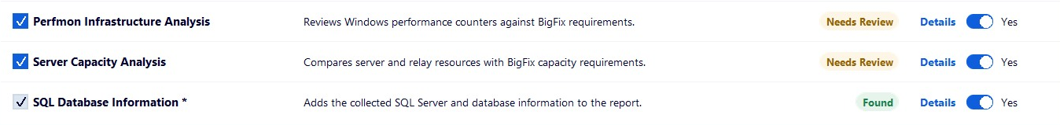
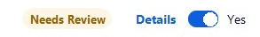
Figure 13. Selected modules marked Needs Review.
- Verify or complete the values inside the open row.
- Use the recording action shown for that module.
- Confirm that the blocking status clears.
Completing the values does not record the review. An edit made after confirmation returns the row to Needs Review until Mark Reviewed is selected again.
Perfmon Infrastructure Analysis uses Mark Reviewed. Confirm the capture host and hardware values before selecting it.
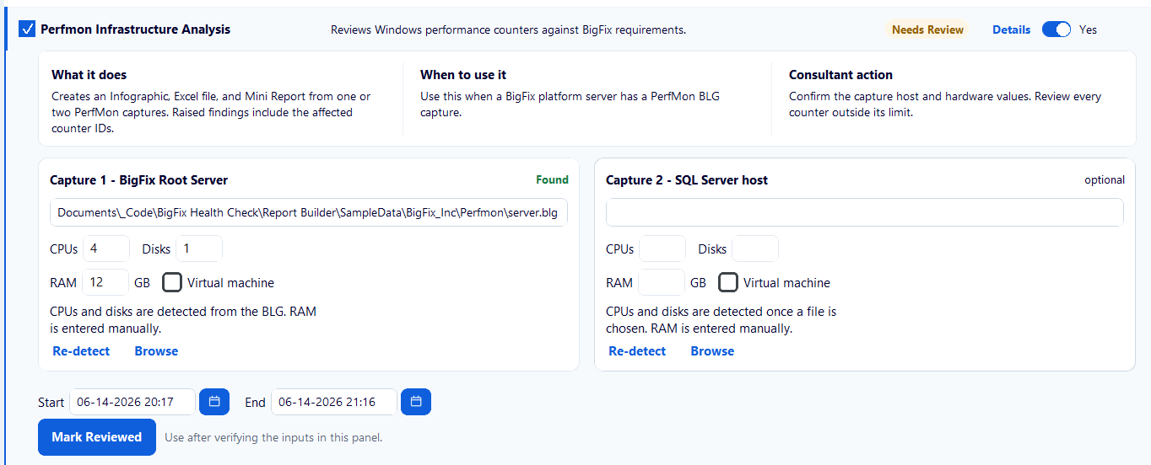

Figure 14. Perfmon Infrastructure Analysis review with Mark Reviewed.
Server Capacity Analysis uses Review hosts and Save and close.
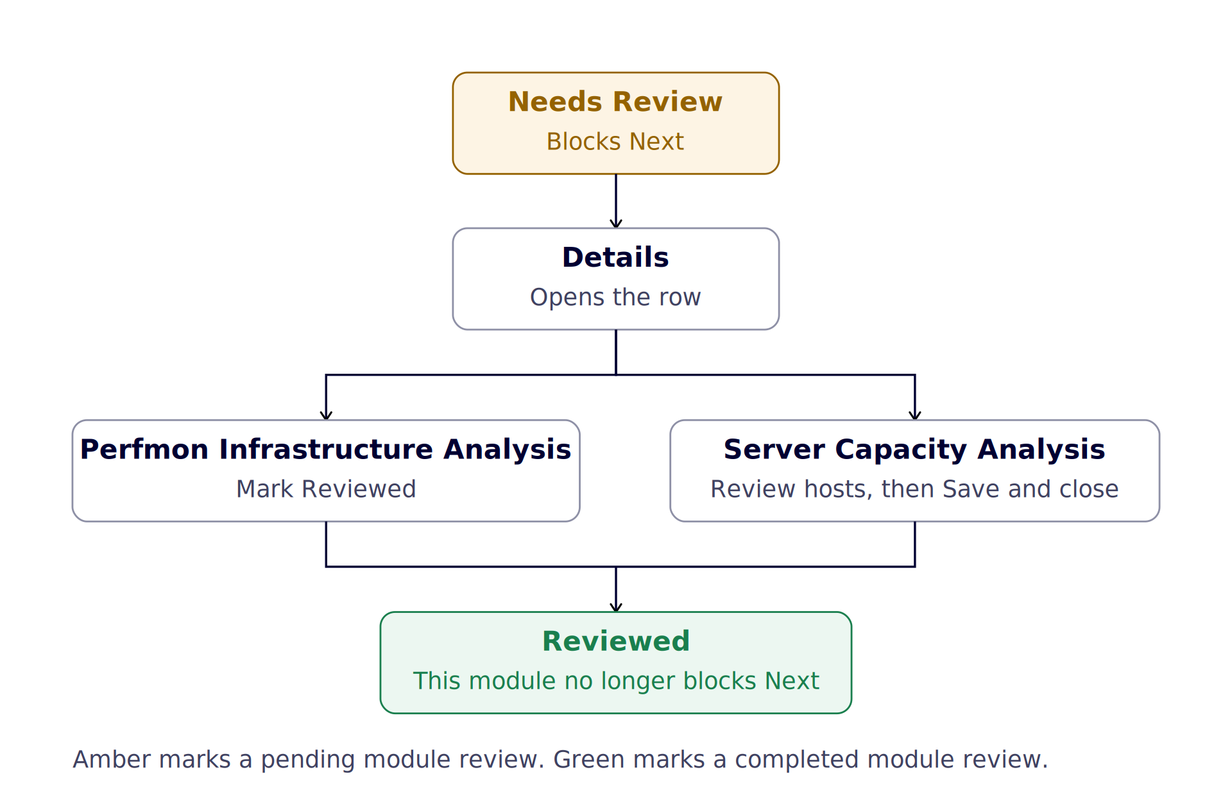
Figure 15. The verified Perfmon and Server Capacity review paths.
FillDB Performance is different. Enter or verify the required collection dates. When the dates are complete, the row no longer requires a separate review action.
Client Loop Health Check requires the report dates in Full Report mode. The report dates are optional in Modules Only. Confirm the detected supporting files when they are present.

6.6 Server Capacity Analysis
- Open Details for Server Capacity Analysis.
- Select Review hosts.
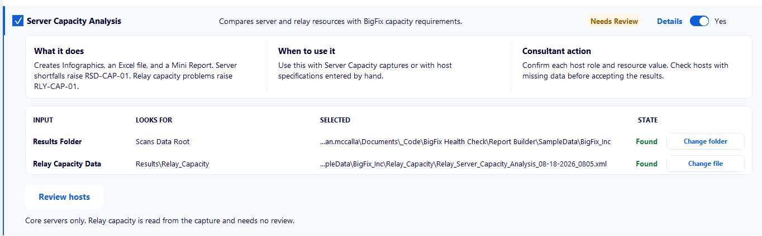
Figure 16. Server Capacity Analysis with Review hosts.
- Confirm Managed Endpoints and review Figures Applied. Confirm every host role and resource value.
- Use Edit to correct a host. Use Add a host when a required host is missing.
- Select Save and close.
- Confirm that the module status changes to Reviewed.
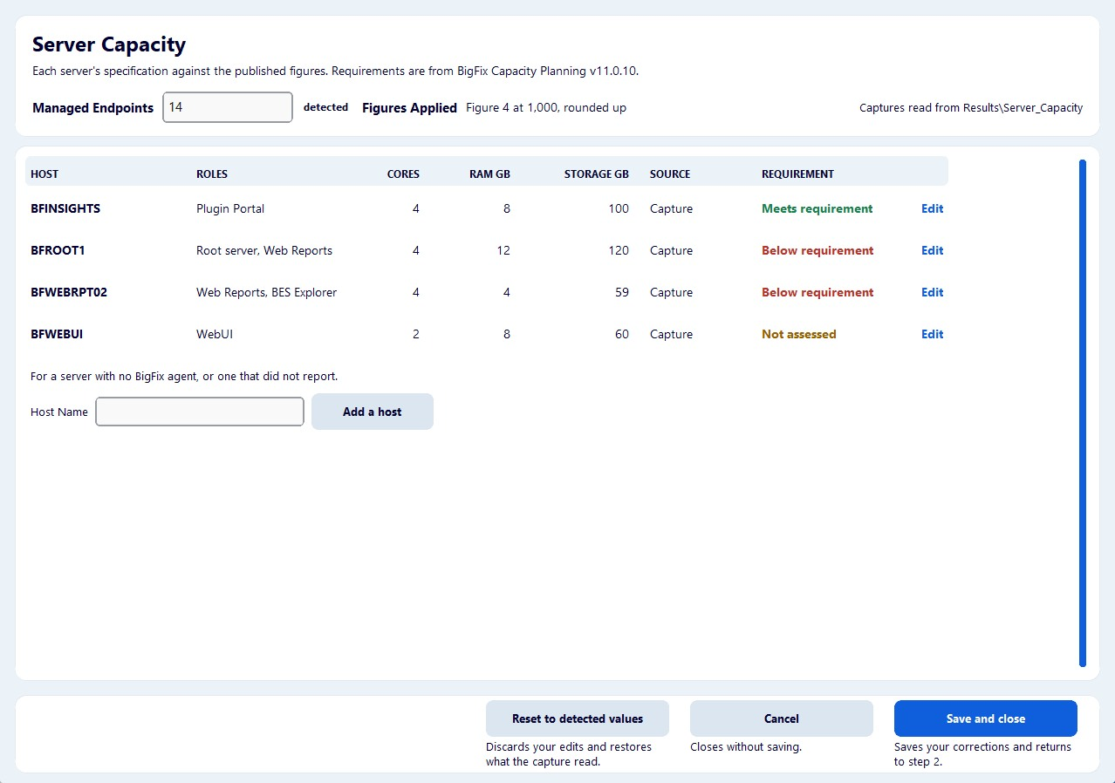
Figure 17. Server Capacity host review.
📝 NOTE Reset to detected values discards edits and restores the captured values. Cancel closes the window without saving.

Result | Meaning
Meets requirement | The reported resource meets the applicable published requirement.
Below requirement | The reported resource is below the applicable published requirement.
No figure applies | The capacity guide does not provide an applicable figure for that role and resource.
Not assessed | A required value is unavailable. This result is not a shortfall and does not raise a finding.

📝 NOTE Not assessed is a Server Capacity result. Not Assessed is an Operational Maturity review state.

6.7 Client Loop Detail
Client Loop Health Check builds these sections when the supporting inputs are available.
- Reading the Infographic. A key to each tile on the Infographic.
- Automated Findings. Shown when the result is not healthy.
- Loop Health. The score, how it is calculated, and reporting issues.
- Loop Cost. The slowest evaluations and the contributing factors.
- Notification and Polling. UDP coverage and command polling, by relay and by subnet.
- Client Settings. FastHashVerify, CPU idle and multicore settings.
The relay and subnet tables show the 10 most affected rows. A note gives the full count when more exist. The workbook keeps every row. Do not replace this detail with only the Client Loop chart.
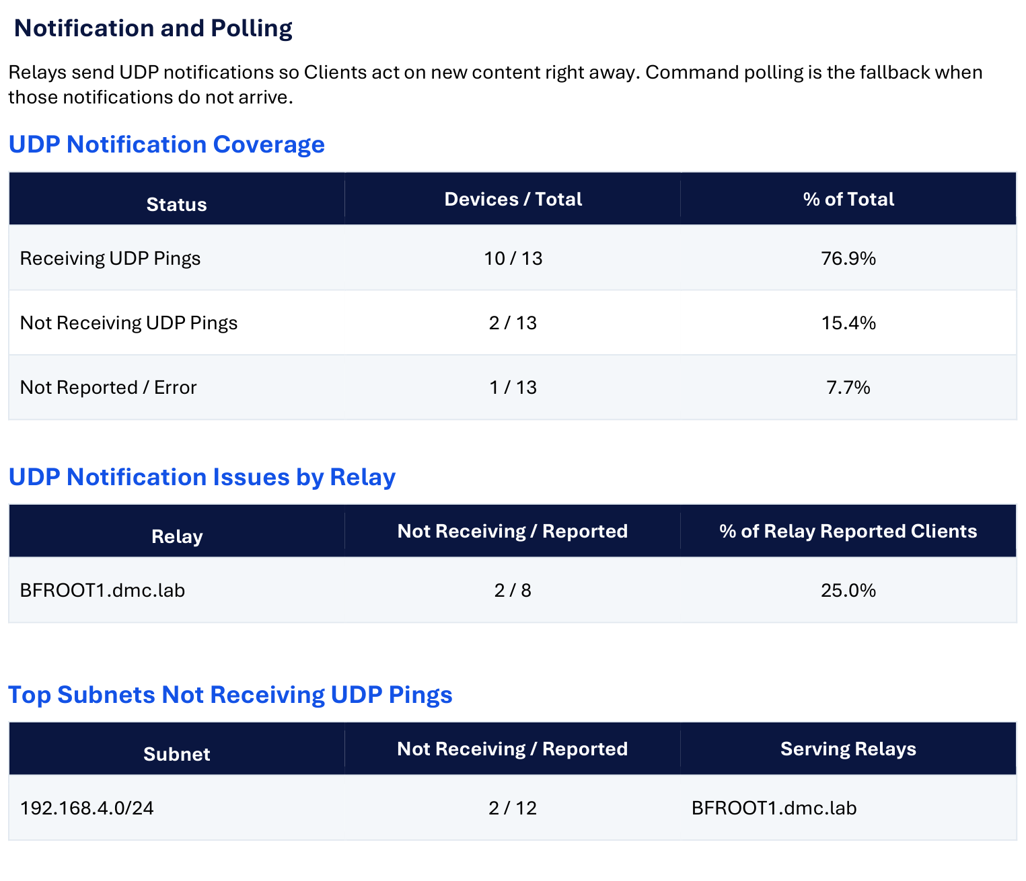
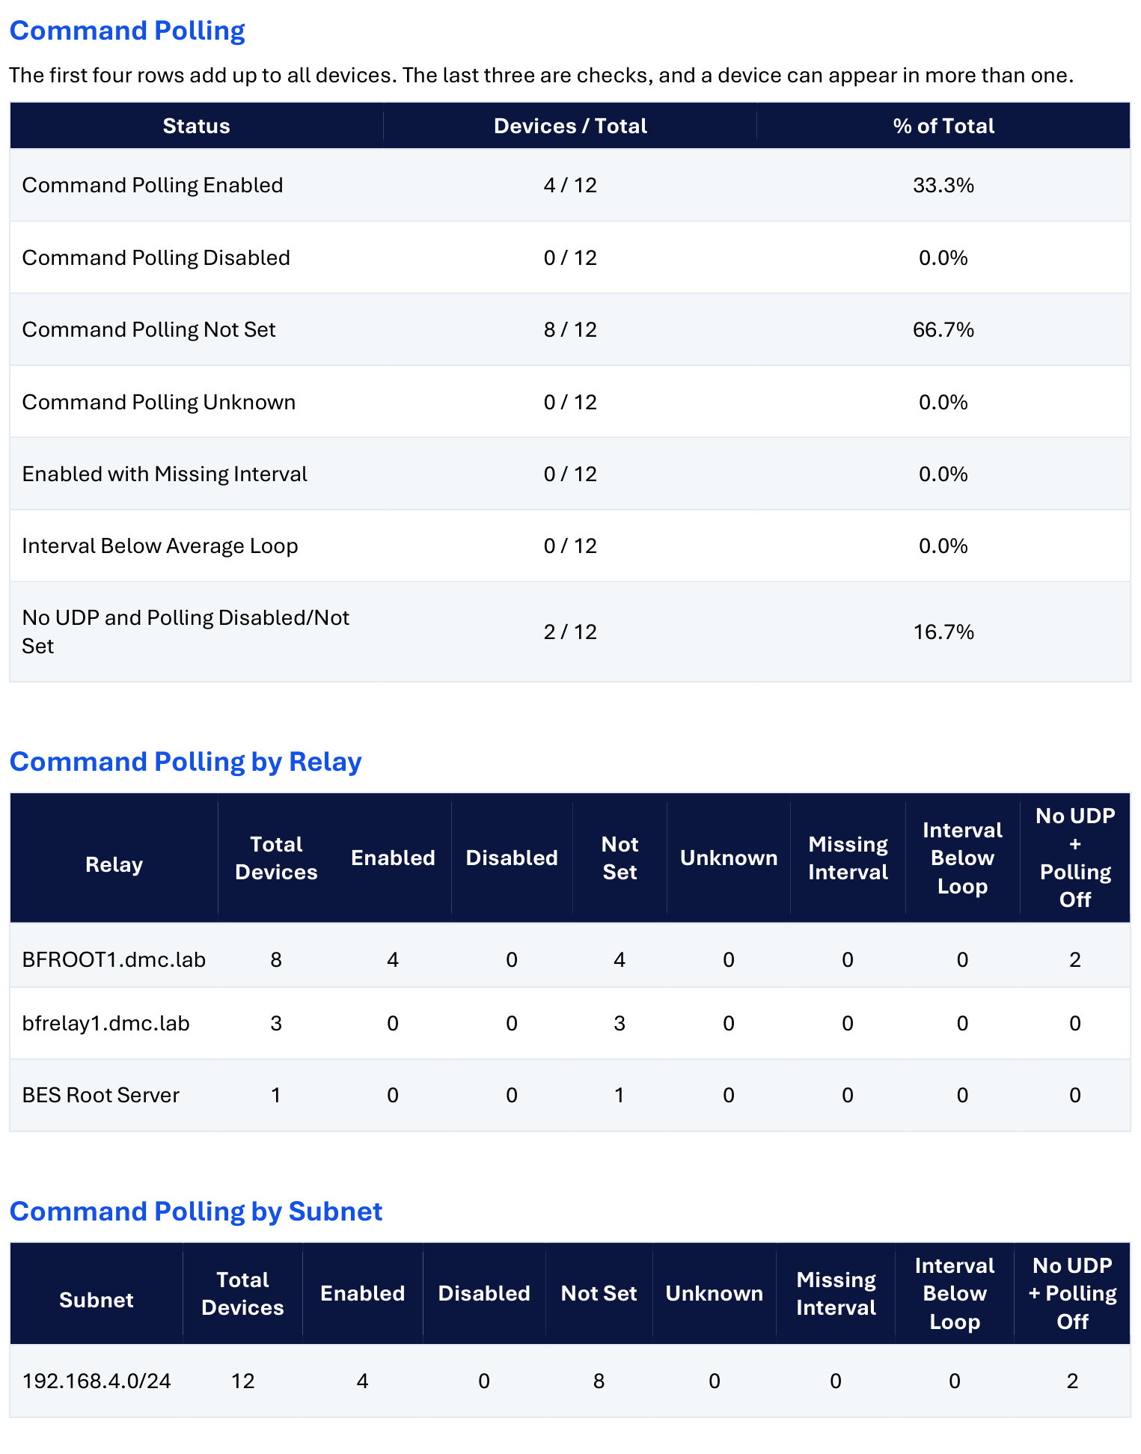
Figure 18. Notification and Polling, with the relay and subnet tables.
Section 07


Step 3: Build

Step 1  Folders | Step 2  Modules | Step 3  Build | Step 4  Validation

Step 3 shows the customer, assessment dates, run mode, selected modules, and output folder. Review these values before starting the build.
Finish Health_Check_Manual_Checks_Capture.xlsx before you select Build. It is the manual check capture sheet from the Procedural Guide. Open it on Day 1 of the collection and fill it in as you go. Its rows are copied into the Findings & Scoring Review workbook at the build pause.
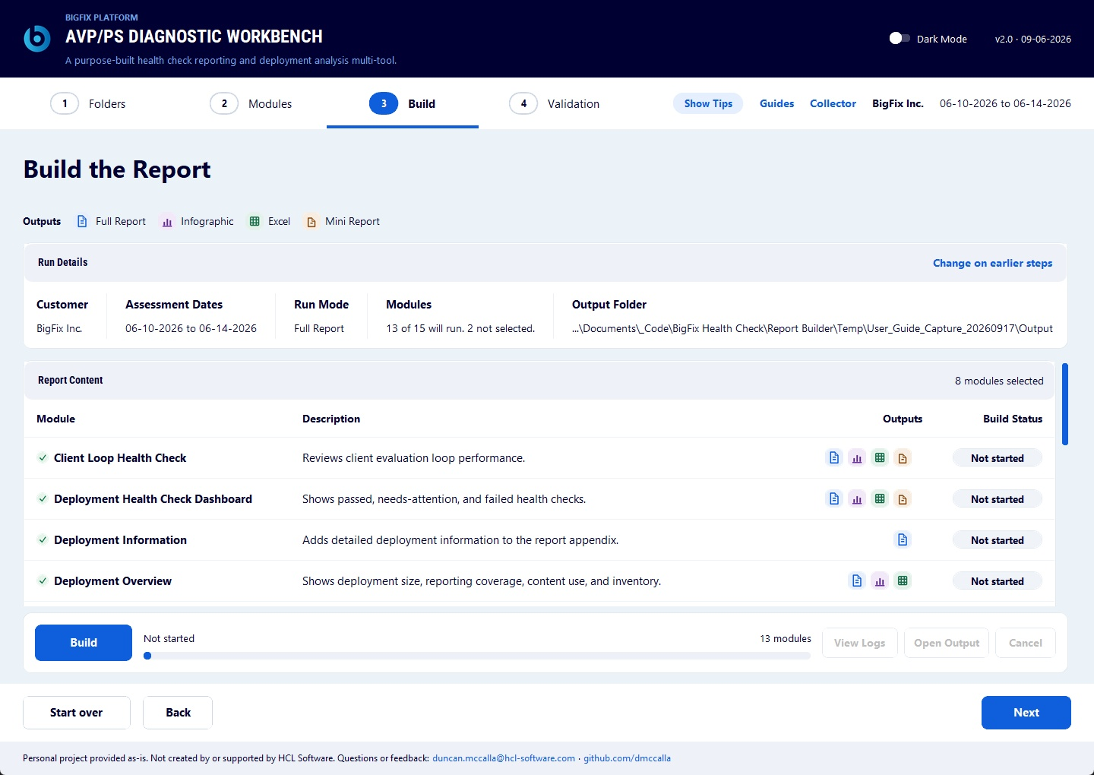
Figure 19. Step 3 before Build.

7.1 Output Terms
Output | Meaning
Full Report | Content added to the main report.
Infographic | An image added to the main report that can also be used separately.
Excel | A separate workbook that supports the module.
Mini Report | A report for one module that can be used separately.

7.2 Build Progress
Status | Meaning
Not started | The build has not started.
Queued | The module is selected for the current build.
Running | The module is running.
Done | The module finished. The row can show its elapsed time.
Failed | The module stopped with an error. Review the run log.

Select Build to start. View Logs opens the current run log. Open Output becomes available when output files exist.
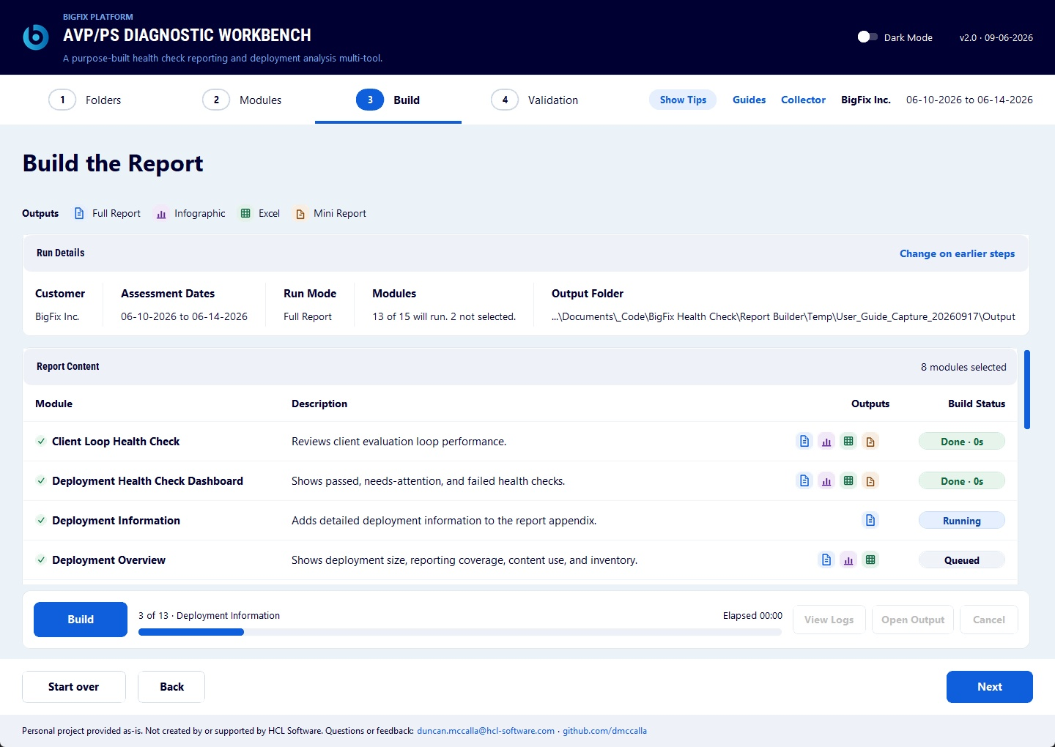
Figure 20. Step 3 build progress.
📝 NOTE When Health Check Findings runs in Full Report mode, the build pauses at Findings & Scoring Review. Review and save the workbook. Select Validate & Continue to resume the build.

7.3 Update Run
An update run creates a new run folder. It does not modify the earlier run folder. See 6.3 Module Dependencies.
Select the modules that must run again. The Workbench can reuse unchanged output from the selected earlier run. On Step 2, the update-source message replaces the required-module line.
Use an update run when new input arrives for one module and the rest of the report is finished. A replacement PerfMon capture is the common case.
- Put the new input where the module can read it. Replace the earlier file in the Data Folder, or select the file on Step 2.
- Start the update run and select the earlier run to reuse.
- On Modules, select only the modules that must run again. The four required-module locks are removed. The Deployment Information dependency still applies.
- Open Details for each selected module. Select the new input. Complete the module review again. For Perfmon Infrastructure Analysis, confirm each capture host and its hardware values before selecting Mark Reviewed.
- Select the findings and executive modules as well when the new input changes findings or scores.
- Select Next. Review the run details on Build. Select Build.
- The build reuses the earlier output for every module you did not select.
- Review and edit the new report. Run Validation. See Section 9.
An update run produces a new report document. Edits made by hand in the earlier report are not carried into it.
Section 08


Findings & Scoring Review

Step 1  Folders | Step 2  Modules | Step 3  Build | Step 4  Validation

The Findings & Scoring review workbook controls findings, scoring, and executive review content.
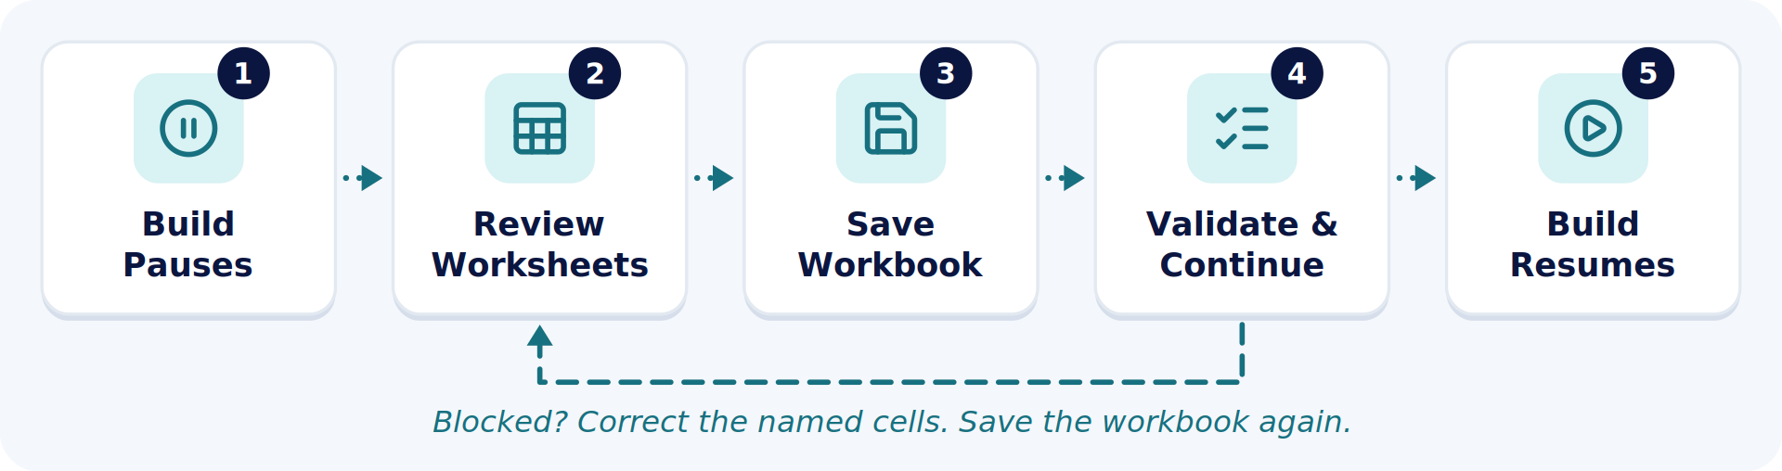
Figure 21. The Findings & Scoring review loop during a Full Report build.

8.1 Worksheets
Worksheet | Purpose
Scoring Data | Show category counts, scores, Operational Maturity review states, and required reasons.
Platform Health Findings | Review included platform findings and Source IDs.
Operational Findings | Record consultant-entered Operational Maturity findings.
Category Map | List the approved scoring categories and report destinations.
What's Working Well | Hold strengths for the executive report.
What Needs Attention | Review the prioritized customer items and their Source IDs.

Release Intelligence is present when that module is included.
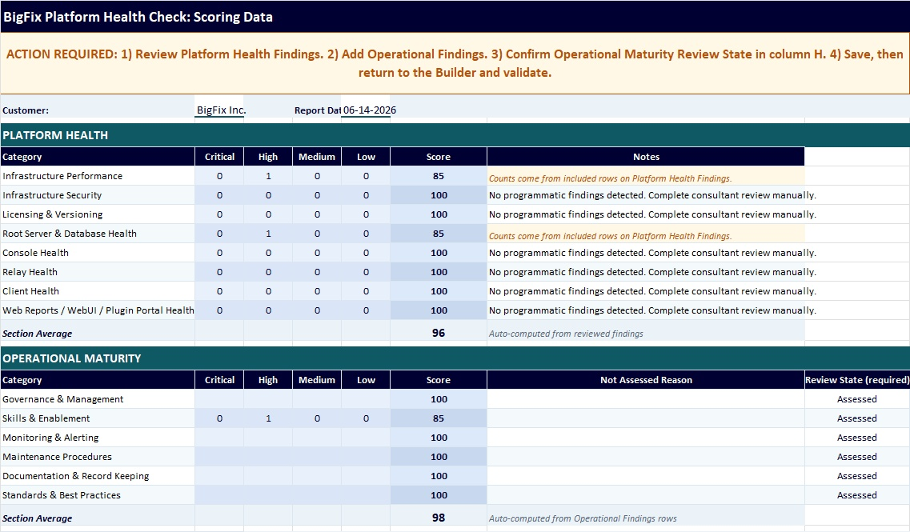
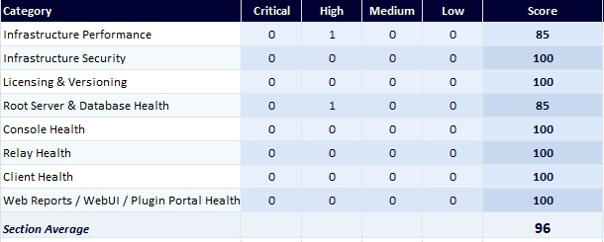
Figure 22. Scoring Data with category scores and review states.

8.2 Platform Health Findings
The primary consultant fields are Included?, Source ID, Category, Finding / Issue, Impact, and Recommended Action.
- Confirm the finding and Source ID.
- Set Included? to Yes only when the finding should enter the report and score.
- Set Included? to No when the finding should be excluded.
- Confirm Category, Impact, and Recommended Action.
- Do not overwrite calculated cells on Scoring Data.
Rows at Review remain excluded until the consultant changes Included? to Yes.
Manual check results come from Health_Check_Manual_Checks_Capture.xlsx. For each check that found a problem copy Source ID, Finding / Issue, Impact, and Recommended Action into the matching columns here.
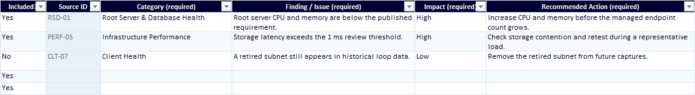
Figure 23. Platform Health Findings with Source IDs.

8.3 Operational Findings
Operational Findings contains five columns.
Column | Action
Included? | Include or exclude the row.
Category | Select an Operational Maturity category.
Finding / Issue | Record the customer-specific issue.
Impact | Select Critical, High, Medium, or Low.
Recommended Action | Record the practical next action.

Operational Findings does not use a Source ID column.
Copy the Operational Maturity rows from Health_Check_Manual_Checks_Capture.xlsx into Category, Finding / Issue, Impact, and Recommended Action.
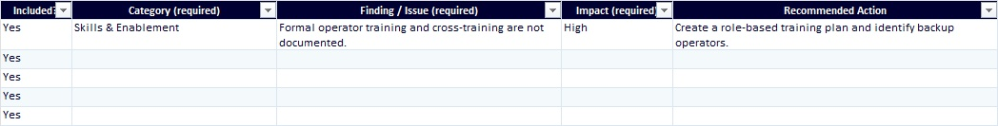
Figure 24. Operational Findings with one consultant row.

8.4 Operational Maturity Review State
Every Operational Maturity category must be Assessed or Not Assessed.
Review State | Action
Assessed | Use after the category has been reviewed. The category can have findings or be clean.
Not Assessed | Use when the category was not reviewed. Enter a reason. The category is excluded from the average.

8.5 What Needs Attention
Confirm Included?, Priority, Category, Finding / Issue, Recommended Action, Source ID, and Target.
Keep each Source ID aligned with the detailed finding.
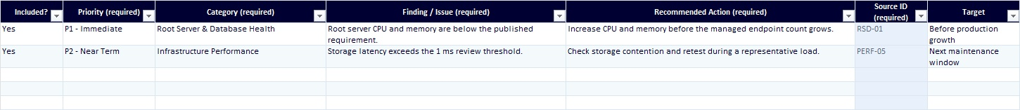
Figure 25. What Needs Attention with priorities and Source IDs.
Save and close the workbook after the review is complete.

8.6 Impact And Remediation Windows
Impact sets the score deduction and the suggested remediation window.
Impact | Score Deduction Per Included Finding | Suggested Remediation Window
Critical | 25 points. | 0 to 2 weeks.
High | 15 points. | 2 to 4 weeks.
Medium | 7 points. | As time permits.
Low | 3 points. | No window is suggested.

The report presents these windows as starting points for planning. The customer can adjust them to fit a maintenance schedule.
A log pattern is rated Critical only when it matches a known serious failure and either recurs or is confirmed by another failed check. A one-off log event is given a lower priority.
Section 09


Step 4: Validation

Step 1  Folders | Step 2  Modules | Step 3  Build | Step 4  Validation

Review and edit the generated report before running Validation.

9.1 Refresh After Workbook Changes
- Save and close the Findings & Scoring review workbook.
- Open Validation.
- Select Refresh from edited workbook.
- Follow Build progress until refresh finishes.
- Return to Validation.
Refresh rebuilds scores, findings-based charts, findings tables, and related report sections. It does not rerun the technical modules.
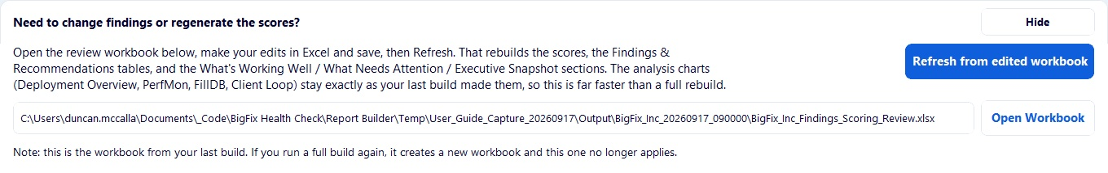
Figure 26. Refresh from edited workbook.

9.2 Run Validation
Select the consultant-updated final report. Select Run Validation.
Result | Action
Blocking | Fix the item before delivery.
Review | Confirm that the item is intentional before delivery.
Passed | No problem was found by the named readiness check.

Select a result row to view its recommendation. Validation can also open the CSV or Excel results and copy the result text.
📝 NOTE Validation checks mechanical report readiness. It does not confirm that the technical findings are correct. It does not replace consultant review, spelling and grammar review, or the Microsoft Word table-of-contents update.
Section 10


Troubleshooting

Problem | Action
The private environment cannot be created. | Close the launcher. Remove the incomplete .venv folder. Confirm write access. Run the launcher again.
Step 1 does not find an input. | Confirm the Data Folder. Select the input through Details on Step 2 when necessary.
A module shows Needs A File. | Open Details and select a valid input. Unselect the module when it is optional.
A module shows Needs Review. | Open Details and complete the module-specific review action.
Step 3 shows Failed. | Open View Logs. Correct the first reported module error. Build again.
Workbook review blocks continuation. | Correct the named worksheet cells. Save the workbook. Select Validate & Continue again.
Refresh cannot start. | Save and close the workbook and report. Retry.
Validation shows Blocking. | Correct every blocking item in the final report. Run Validation again.
A chart cannot be rendered. | Confirm that Microsoft Edge or Google Chrome is installed. Rerun the affected module.
Section 11


Delivery Gates

Complete every gate before you deliver a Full Report.
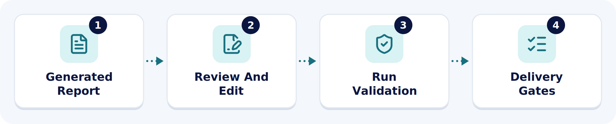
Figure 27. Validation runs after the report is edited, not after the first draft.
# | Delivery Gate | Done
1 | Confirm that every selected module was ready before Step 3. | ☐
2 | Complete Findings & Scoring Review when the build pauses. | ☐
3 | Confirm every included Platform Health finding. | ☐
4 | Record Operational Findings and every Operational Maturity review state. | ☐
5 | Review What's Working Well and What Needs Attention. | ☐
6 | Confirm that workbook review validation passed or that an authorized override was recorded. | ☐
7 | Run refresh after the final workbook change. | ☐
8 | Resolve every Blocking result in Validation. | ☐
9 | Complete consultant and peer review of the final report. | ☐

📝 NOTE Treat every generated file as customer confidential operational information.
Section 12


Security And Data Handling

12.1 Local Processing
Report creation runs locally. The Workbench reads the files the consultant selects and writes results to local folders. It does not connect to live BigFix or SQL systems, upload customer data, or require customer credentials.
Collection is separate. The collection tasks run in the BigFix console under a dedicated temporary account created by the customer. See 1.1 Requirements.
Automated tests enforce this boundary. Network-capable libraries and socket connections are prohibited in the report-building pipeline.
The Release Intelligence Collector and the vulnerability-enrichment tools are the exception. They run separately and can use internet sources. Review their output and save it locally before you supply it to the Workbench.

12.2 The Private Python Environment
uv creates and manages the private Python environment of the Workbench. It installs the exact versions recorded in the cross-platform uv.lock file, so the Workbench does not depend on packages in the global Python installation. See 2.1 Install Python.
Routine dependency updates apply a seven-day adoption delay. This reduces exposure to a newly published package during the period when a malicious or compromised release is most likely to be found and removed.

12.3 Data Handling Rules
- Collect only the information needed to perform the assessment and support its findings.
- Transfer customer data through approved HCL Software or customer-approved mechanisms. Process it in an approved working environment.
- Never collect credentials, tokens, private keys, or password-bearing files. Keep them out of profiles, logs, reports, screenshots, test data, and delivery packages.
- Limit access to customer information to the personnel performing the assessment.
- Run collection under a dedicated temporary BigFix account. Do not use a personal account or an existing service account. The customer disables or removes the account when collection is complete.
- Treat reports, workbooks, charts, logs, exports, and intermediate files as customer confidential.
- For engagements under enhanced regulatory, privacy, or government requirements, including GDPR and CFIUS obligations, customer data is processed in dedicated controlled environments that add isolation, access controls, and auditability.
- Deliver the final reviewed report. Supporting files remain internal unless their release is approved.
- After delivery, retain, archive, or remove customer data and intermediate files according to HCL policy, customer requirements, and the regulatory obligations of the engagement.

12.4 Layered Security Controls
Security was designed into the Workbench from the start. It is not a final code scan. The program covers application architecture, network access, dependency management, source code, data collection, customer-data handling, generated files, and release approval.
The project does not depend on a single commercial security platform. It uses independent controls, so the limits of one tool are covered by another. Each control is transparent, automatable, actively maintained, and suitable for repeatable command-line checks.
Layer | Control | Why It Was Selected
Tests And Guardrails | pytest | Runs the regression suite and the project-specific security guardrails. It is mature, readable, and scalable, with a large Python plugin ecosystem.
Lint And Format | Ruff | Runs fast lint and formatting checks. It consolidates checks traditionally handled by Flake8, isort, pyupgrade, and other tools into one gate.
Static Analysis | Bandit | Examines Python syntax trees for common security problems. It provides a Python-specific security pass independent of the lint rules.
Static Analysis | Semgrep | Runs semantic static analysis and supports security rules that identify unsafe code patterns across files and functions.
Dependencies | pip-audit | Audits the environment and dependency tree for publicly reported vulnerabilities. It is maintained under the Python Packaging Authority.
Dependencies | Snyk | Adds independent dependency and source-code scanning when authenticated. It builds a dependency graph and checks direct and transitive packages against its vulnerability database.
Secrets | Gitleaks | Scans files and Git history for passwords, tokens, API keys, and other embedded secrets.
Secrets | TruffleHog | Provides a second secret-scanning engine. It can distinguish a potential credential from one that appears active.
Inventory | CycloneDX | Produces a machine-readable software bill of materials. CycloneDX is an OWASP project and the ECMA-424 international standard.
Inventory | pip-licenses | Inventories third-party package licenses, so a licensing problem is identified before release.
Code Health | mypy | Runs static type analysis to identify incompatible values and incorrect function use without executing the code.
Code Health | Vulture | Finds unused and unreachable code that can conceal obsolete behavior or untested paths.

The overlap is deliberate. Bandit, Semgrep, Ruff, and Snyk examine different classes of source-code problem. pip-audit and Snyk provide separate dependency checks. Gitleaks and TruffleHog provide independent secret scans. No single scanner is treated as authoritative.
Dependency updates, vulnerability lookups, and external code scans are maintenance activities. They run against project code and dependency information, outside customer-data workspaces.

12.5 The Release Sweep
The complete security and quality sweep runs through the controlled uv environment, so every run performs the same checks in the same environment. It covers dependency age, automated tests, formatting, source quality, vulnerable packages, unsafe code patterns, embedded secrets, third-party licenses, the software component inventory, type consistency, and unused code.
The sweep runs on a weekly schedule and before every release.
Each run creates timestamped Markdown and JSON reports.
Result | Meaning
Clean | No gate reported a problem.
Review Recommended | The run raised items for review before release.
Action Required | The run raised items that must be resolved before release.

A failed required gate, a high-risk issue, an unresolved secret, or a dependency vulnerability blocks the release. The release owner can review the finding and accept the risk explicitly.
When an optional scanner is unavailable or is not authenticated, the run records that condition. It is never reported as a successful scan.
No scanner can prove that software is free from every defect. The strength of the program comes from combining independent tools, enforced architectural boundaries, automated tests, documented review, and a release decision based on the complete set of results.
See the Workbench security documentation for the complete program.

12.6 Answering Customer Questions
Question | Answer
Does the Workbench connect to our BigFix or SQL systems? | No. It reads the files the consultant selects and writes results locally. Automated tests prohibit network-capable libraries and socket connections in the report-building pipeline.
Does it need credentials for our environment? | No. The Workbench reads collected files. Collection runs in the BigFix console under a dedicated temporary account that you create and then disable. Credentials, tokens, and private keys are never collected or stored.
Does anything go online? | Only the Release Intelligence Collector and the vulnerability-enrichment tools. They run separately, and their output is reviewed and saved locally first.
How do you know the dependencies are safe? | uv installs the exact versions recorded in uv.lock. Routine updates apply a seven-day adoption delay. pip-audit and Snyk check the dependency tree against published vulnerabilities.
Is there a software bill of materials? | Yes. CycloneDX produces a machine-readable bill of materials. CycloneDX is an OWASP project and the ECMA-424 international standard.
What stops a risky release? | A failed required gate, a high-risk issue, an unresolved secret, or a dependency vulnerability. The release owner must review the finding and accept the risk explicitly.
Where does our data go? | It moves through approved HCL Software or customer-approved mechanisms and is processed in an approved working environment. See 12.3 Data Handling Rules.
Appendix A


Module Reference

Step 2 shows fifteen modules in three groups. This appendix describes each module and what it needs to run on its own. On Step 2, the open row of a module shows what it does, when to use it, and the inputs it looks for. Step 3 shows the outputs each selected module will produce.
Label | Meaning
Required For Full Report | The module is selected automatically for a new Full Report. It cannot be cleared.
Separate Files Only | Into Report is unavailable. The module produces separate files only.
Experimental | The output stays in separate files. It does not enter the Full Report or the review workbook.

Report Modules | Findings and Narrative | Experimental Modules
Client Loop Health Check | Health Check Findings (Check Table Cells) | Client Settings Suggester
Deployment Health Check Dashboard | Release Intelligence | Server Log Analysis
Deployment Information | What's Working Well
Deployment Overview | What Needs Attention
FillDB Performance | Health Check Analysis (Supporting Reference)
Perfmon Infrastructure Analysis
Server Capacity Analysis
SQL Database Information

A.1 Report Modules
Client Loop Health Check | Reviews client loop timing, UDP notification status, command polling settings, relay detail, subnet detail, and slow evaluations when the supporting inputs are available.  - Input. The loop counter export. It can be a Client_Loop XML or CSV file or an Agent Performance Counters - Basic Excel or CSV export. The Deployment_Information folder is required. The Top 10 slowest evaluations and the UDP notification export are optional.  - Step 2 Review. Requires the report dates in Full Report mode. The report dates are optional in Modules Only. Confirm the detected supporting files when they are present.  - Detail. The output opens with a key to the Infographic. It then covers Loop Health, Loop Cost, Notification and Polling, and Client Settings. See 6.7 Client Loop Detail.  - Findings. A non-healthy result uses Source ID CLT-01.

Deployment Health Check Dashboard  Required For Full Report | Builds the dashboard section and related outputs from the same data shown in the BigFix Console dashboard.  - Input. The Deployment_Healthcheck_Dashboard XML capture. A legacy .log or .txt capture also works.  - Findings. Failed and Needs Attention checks carry their Source IDs into the chart and finding flow.

Deployment Information  Required For Full Report | Adds deployment reference tables to the Full Report.  - Input. The folder of deployment information logs from the Collect Deployment Information task.  - Dependency. Health Check Findings (Check Table Cells), What's Working Well, Health Check Analysis (Supporting Reference), and Client Settings Suggester select this module automatically. It cannot be cleared while any of them remains selected. See 6.3 Module Dependencies.

Deployment Overview  Required For Full Report | Builds the overview outputs from the same data shown in the BigFix Console dashboard.  - Input. The Deployment_Overview_Dashboard XML capture. A legacy .log or .txt capture also works.  - Detail. The Deployment Overview does not show an overall result in its top-right corner.

FillDB Performance | Reviews FillDB processing performance and its collection period.  - Input. FillDBperf.log or an analyzed CSV. The Workbench combines rolled-over log sets automatically. Select any one log or the folder.  - Step 2 Review. Enter or verify the required collection dates. When the dates are complete, the row no longer requires a separate review action.  - Findings. A below-threshold result uses Source ID RSD-06.

Perfmon Infrastructure Analysis | Reviews PerfMon counters and requires host hardware confirmation.  - When To Use It. Use this when a BigFix platform server has a PerfMon BLG capture.  - Produces. An Infographic, an Excel workbook, and a Mini Report from one or two PerfMon captures.  - Input. A Windows .blg file from the PerfMon capture. PerfMon analysis runs on Windows only.  - Step 2 Review. Confirm each capture host and its hardware values before selecting Mark Reviewed. One PerfMon capture is required. A second capture is optional.  - Findings. The finding area lists the Source IDs for the affected counters.

Server Capacity Analysis | Compares reviewed server and relay resources with published BigFix capacity figures.  - When To Use It. Use this with Server Capacity captures or with host specifications entered by hand.  - Produces. Infographics, an Excel workbook, and a Mini Report.  - Input. The Results folder. Relay capacity data from Results\Relay_Capacity is optional.  - Step 2 Review. Open the review with Review hosts. Record it with Save and close. See 6.6 Server Capacity Analysis.  - Findings. Server shortfalls use Source ID RSD-CAP-01. Relay capacity problems use RLY-CAP-01.

SQL Database Information  Required For Full Report | Adds collected SQL Server and database information to the Full Report.  - Input. The SQL database information export (.csv or .txt) from the SQL scripts.

A.2 Findings and Narrative
Health Check Findings (Check Table Cells) | Creates report findings, the remediation tracker, and the Findings & Scoring review workbook.  - Input. The data collection root folder.  - Dependency. Selecting this module also selects Deployment Information.  - Detail. In Full Report mode, the build opens the Findings & Scoring review workbook and pauses. See Section 8. A Modules Only run does not pause.

Release Intelligence | Adds locally collected release and known-issue information for upgrade planning.  - Input. Run the Release Intelligence Collector first. Open it with Collector in the header. The module reads the release intelligence JSON file. A CSV file provides changelist rows only. CVE enrichment data is optional.  - Produces. Matching Full Report appendix and Mini Report content, plus Excel. It does not change scoring.  - Detail. The review workbook includes a Release Intelligence worksheet when this module is included.

What's Working Well | Builds confirmed strengths for the executive section.  - Detail. The What's Working Well worksheet holds these strengths for review.  - Dependency. Selecting this module also selects Deployment Information.

What Needs Attention | Builds the highest-priority reviewed findings for the executive section.  - Detail. Review priorities and Source IDs on the What Needs Attention worksheet. See 8.5 What Needs Attention.

Health Check Analysis (Supporting Reference)  Separate Files Only | Creates separate consultant reference files. It does not update the Full Report findings or scoring workbook.  - Dependency. Selecting this module also selects Deployment Information.

A.3 Experimental Modules
Experimental Module output stays in separate files. It does not enter the Full Report or the review workbook. All Available selects every module that can currently run. This includes Experimental Modules.
Client Settings Suggester  Experimental  Separate Files Only | Creates separate Excel and Mini Report outputs.  - When To Use It. Use this to prepare client setting suggestions for a tuning discussion.  - Input. A data root that contains the Deployment_Information folder.  - Dependency. Selecting this module also selects Deployment Information.

Server Log Analysis  Experimental  Separate Files Only | Creates a separate Excel output from collected server logs.  - Input. The extracted Collect BES Logs folder.

